**ETHAN WILLIAMS – INDIVIDUAL REPORT: GARAGE GLIDE**

Introduction

For my group project, we created a web application called Garage Glide. This was designed to simplify the process of locating a nearby garage using a postcode, scheduling vehicle services, and for garage managers, tracking the performance of their services through customer feedback. We chose to use the React framework for its suitability to our project goals.

In this report, I will discuss my progress and my overall contribution to the project. I'll talk about the skills I've improved, both technical and teamwork, and the reasoning behind the design choices I made. This report will reflect on what I've learnt, the challenges we faced and areas where the project can still improve.

Individual Contribution :

As a group, we decided that another team member would work on the front-end side of things whilst the three other group members would focus more on back-end functionality and project management. But we didn't stick to this at all times, occasionally dipping into some back-end features. But the majority of the front-end tasks fell to me and another member.

* **Created selected centre functionality:** allows to choose service centres
* API integration collaboration: Collaborated with back-end team members to display the car registration and postcode
* **Service page development:** showcasing all the services we provide, going deeper and showcasing specific services
* **Booking system:** introduced system to add car registration, postcode, selected date and time, allowing to be booked into the basket
* **Search bar:** search bar for direct navigation to specific services
* **Feedback:** shows satisfaction rates and a table that shows customers' ratings allowing the manager to reply to them in real-time, also showing a star rating
* **Calendar function:** real-time calendar with colour-coded event status
* **New booking process:** designing a new booking procedure with account activation
* **Car information feature:** enabled car detail retrieval via car registration
* **Interactive event pop-ups:** created pop-up events for details to easily access

The selected centre functionality was a pivotal feature that allows users to choose between the different service centres, Canterbury and Medway. This addition notably enhances the user's experience by offering more personalised and localised services. The implementation went smoothly, with the feature being well received by the users for its ease of use. One challenge faced was ensuring the systems accurately reflected the availability depending on the postcode, so postcodes closer to Canterbury showed the Canterbury service centre. Resolving this issue depended on my understanding of data management and the importance of communication with the back-end team.

The real-time calendar function stood out as one of the most critical elements of the project for me, making sure to enable the booking and schedule management through the colour-coded display of different statuses for appointments. The integration of this feature was successful and improved efficiency. However, difficulties arose when trying to sync the calendar with live updates from the backend, especially when handling concurrent bookings. Overcoming these difficulties taught me valuable lessons in management with react and the need for more testing of real-time features to ensure a better user experience.

The booking system was crucial in the project, allowing users to add their car details and selected services, allowing the reservation process. While the user interface was praised for its simplicity, the initial feedback indicated that some users found the car registration input confusing. So refining this showed me the importance of user-centred design and iterative development based on user feedback.

Lastly, the feedback system creation was an essential feature that provided insight into customer satisfaction and service quality. While the implementation was successful, it still provided challenges along the way, which was ensuring the feedback was only shown depending on who had signed in from the selected centre. Initially, the feedback wouldn't show correctly, however, the correct testing and speaking with my team member who had already done something similar allowed me to show the desired outcome.

These features and learning outcomes from their challenges have contributed to my growth as a developer. They truly show the nature of software development and the constant need for alignment between the user's needs and technical execution.

Activities and Outcomes

With the being a group project, the five of us all had different tasks to focus on. Before diving into coding the project we agreed to do extensive research to identify the best practices for web development and user experience design. This was crucial as it ensured that the platform would meet the needs of both customer car owners and garage managers. Throughout the development process, I was in constant contact with Dr Kemi Ademoye, with her expertise she was able to help not just me but all of the team members throughout the project with the complex challenges we encountered. One of the more challenging aspects of the project emerged while developing the 'Calendar' component. The integration of dynamic booking functionalities with real-time updates presented a frustrating roadblock for me, primarily due to the complexity of managing the state within React and syncing with the backend API. After around a two to three-week period of thorough debugging and iterative testing, I managed to overcome this hurdle. Assistance from my team members and Kemi was pivotal, by having regular meetings with them both having pair programming sessions and regularly checking Stack Overflow as other people had experienced similar issues and had described how they fixed them, I was able to refactor the code for state management, enhancing the performance and reliability of the calendar feature allowing it to work perfectly as I wanted.

Design rationale

The calendar component, a central feature of our garage management system, was crafted with the explicit purpose of streamlining the booking process for automotive services. Designed to give the user a more interactive experience when using and adding to the component, providing a platform for managing garage appointments. The creation of the Calendar was driven by a tool that would offer simplicity and efficiency. Its interface is laid out to present a clean and organised view of bookings, which can be crucial during busy garage operations. With its user-centric design, the garage staff can easily navigate through the days, weeks and months, planning and adjusting schedules with minimal effort. Recognising the importance of quick visual processing in a fast-paced environment, the calendar employs a thoughtful colour-coding system. This not only enhances the visual appeal of the interface but also serves as a functionality purpose. Different colours are used to represent various types of services, such as red for a cancelled booking, blue for a pending booking and green for a confirmed booking. The choice of this is rooted in cognitive psychology, where colour association plays a significant role in memory and recognition. The sidebar is the system's navigation, deliberately designed to be accessible. It serves as a command centre, from where the users can access all the necessary functions without cluttering the main space. The overall layout of the Calendar page tries to keep a minimalist design, reducing unnecessary elements that could distract from the primary task of booking management. The interface spacing and button design all contribute to an experience that feels both modern and efficient. The users who have tested this feature have found it very easy to navigate through and achieved the main decision goal

Evaluation of the project

The project prototype successfully demonstrates the core functionalities expected of a well-built booking and management system. It serves as a concept of how such a system can modernise and Improve within a local garage. This prototype offers a glimpse into a future where digitalisation and auto services come together to improve customer and management satisfaction, enhancing experiences on both sides.

Despite its achievements, the project still has areas for improvement needing further development before it can be considered a fully working operational system. With the system features, they don't fully extend to what is desired with garage services, such as service customisation for different vehicle types or varying needs for customers. Additionally, the system's current functionality for managing irregular scheduling scenarios like special promotional events requires further refinement, this is vital to capture the real-life scenario of a garage. A good avenue to explore for future enhancements is the implementation of service packages. Customers often require a suite of services rather than isolated tasks; hence, a feature enabling the booking of combined services, like an oil change grouped with brake repairs and a diagnostic check, adding could significantly improve operational flow. This addition would not only simplify the booking process but could also provide opportunities for offers for customers.

My contributions to the project, particularly in implementing dynamic scheduling and refining the user interface, were very crucial in pushing the project towards this innovative edge. The feedback we received from our online forum, on these features suggests that the prototype is well-received and has the protentional for reaching real-world applications While the project so far lays down a very strong foundation, these future enhancements could bring its full potential. It captures a well-organised strategy for evaluation, positioning the systems needs of garage management. The advancements I contributed, especially in the dynamic scheduling and user interface design, are indicative of the project's capacity for further innovation and its readiness for the next stages of development and refinement.

If I were to start the project again, I would integrate more frequent user testing within the project to better align the final product with the user's actual needs and expectations. I would also prioritise implementing a notification system to keep users informed about their bookings and any changes in the schedule. This could include automated reminders for upcoming appointments and real-time notifications for any changes or cancellations. This feature would dramatically enhance the user's experience and reduce the likeliness of missed appointments.

Feedback Received

So from my perspective, I asked my friends and family to pretend to be car owners (customers) and garage managers (staff) to give me feedback from the perspective these to help build and improve the project. I received feedback from both parties

Feedback from car owners has been beneficial in refining the booking system. With initial user testing revealed that the simplicity of the interface was well-received, allowing for good navigation and interaction. However, some users showed a desire for more personalisation within the project, such as the option to favourite services or set recurring appointments. This input has highlighted some more customisation features that need to be added to enhance user satisfaction.

Garage members provided insights into the functionality of the system. They liked the booking process and in-chat feature with customers leaving reviews improving garage efficiency. Some managers noted the system could improve by having more flexible scheduling tools to accommodate peak times and emergency bookings, which is common in garage operations.

The development team felt that the project was a strong collaborative effort that incorporated everyone’s strengths. Challenges were frequently discussed in meetings, showing a supportive environment and a collective problem-solving mindset. Team members regularly future projects that could benefit from even earlier prototyping and more frequent iterations, this could help identify potential issues sooner and align the project more closely with user needs.

Having a forum for users to give feedback on the project was beneficial to see it from people in the project fair without having a biased view towards us. The feedback received has been highly encouraging, with an average rating of around 4.4, it is evident that the majority of people find it user-friendly.

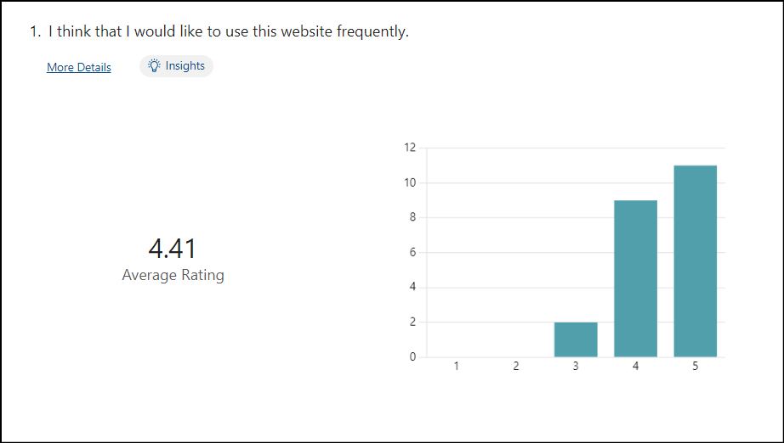

Areas of improvement and feature requests:

The forum also allowed valuable insights into more specific features use would like to see implemented to improve the booking system. For example, there were multiple requests for features such as :

* The ability to check MOT's history by entering the registration plate, will link to a functionality that ties into a car maintenance
* A need for an email confirmation system, which would link to a better booking process
* A call for a more detailed car history section and a user-friendly login prompt, which suggests users are looking for a more personalised and secure experience.

These insights help to push the project in the right direction into future development. These responses not only reflect the user's engagement level but also outline a clear opportunity to enhance the current booking system.

In response to the feedback received, in the future, if we had more time to work on the project, I would have prioritised these features within phases of the project to improve user experience. This would help build a loyal user base that will feel heard and valued, as their suggestions will be visibly evident in the evolution of the platform.

Reflections on the project

This project showed the importance of effective teamwork in achieving complex objectives. Working in a diverse group of five, each with different skills and perspectives has taught me the importance of communication and support between us. Regular weekly meetings and pair programming, not only helped with problem solving but helped with sharing knowledge across the team. This experience has highlighted the value of a collaborative approach, where different viewpoints can help improve the project dramatically.

Working with React and TypeScript provided useful insights into their strengths and suitability for dynamic web development. Reacts component-based structure was ideal for managing the interactive elements of our service booking system, while typescript enhanced code reliability by preventing common errors. Using both these technologies has given me invaluable hands-on experience and a better understanding of their operational strengths and weaknesses in a real-world environment.

This project, really challenged my technical skills and encouraged a more significant personal development. It refined my problem-solving abilities, pushed me to develop new skills and enhanced my capacity to work as part of a team, preparing me for more future professional challenges.

This report outlines a thorough account of the work I've put into Garage Glide, detailing the significant challenges I faced and how I tackled them. The successful implementation of core functionalities, like the real-time calendar and enhanced booking system, underlines the quality of my contribution to the project. I've demonstrated resilience in problem-solving and an ability to innovate based on user feedback, which are critical skills in software development. Given the complexity of the issue resolved and the initiative shown in developing key features, I believe my efforts merit a high mark. These are not just solutions to technical problems; they are meaningful improvements that have a real impact on the user experience.

Appendix :

**Selected centre**

**Services 1**

**Services 2**

**Services 3**

**Search bar**

**Manager 1**

**Manager 2**

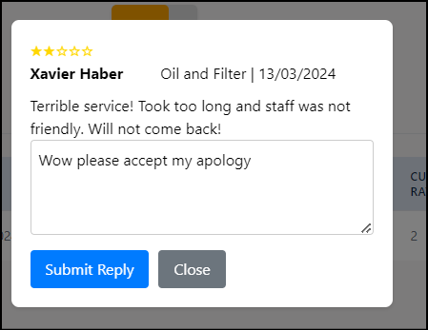

**Manager 3**

**Calendar 1**

**Calendar 2**

**Calendar 3 Calendar 4**

**Calendar 5 Calendar 6**

**Calendar 7**